**Walk Jog Ranch Trail**

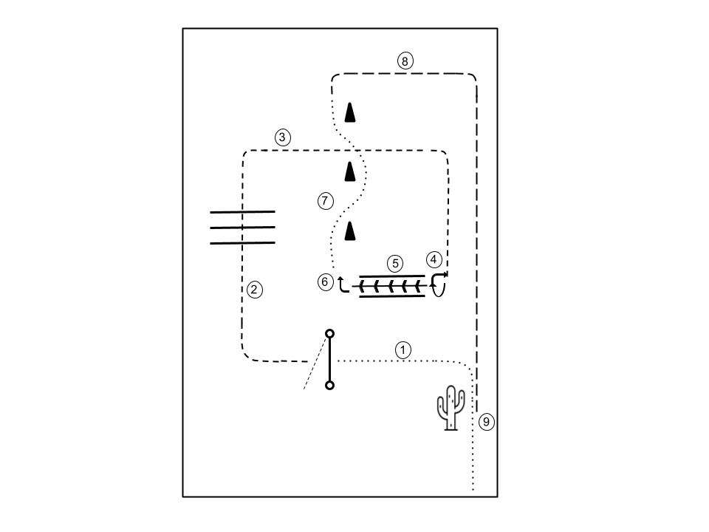

1. Enter at a walk. Walk to gate. Open gate, right hand push.
2. Trot over poles
3. Trot to back through
4. 270° turn to the right
5. Back through chute
6. 90° turn to the left
7. Walk through cones as shown
8. Extended trot to cactus
9. Stop at cactus, pick up rain slicker, return to cactus. Exit at the walk.

**Beginner, Amateur, and Open Ranch Trail**

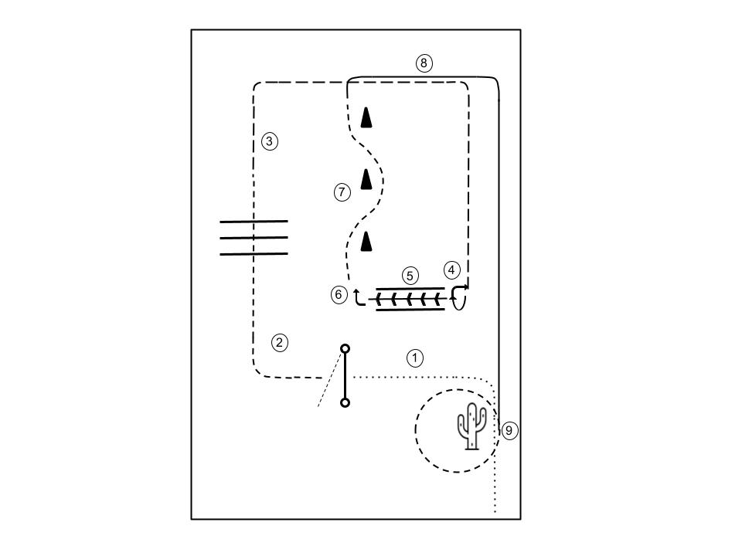

1. Enter at a walk. Walk to gate. Open gate, right hand push.
2. Trot over poles
3. Extended trot to back through
4. 270° turn to the right
5. Back through chute
6. 90° turn to the left
7. Trot through cones as shown
8. Right lead lope to cactus
9. Stop at cactus, pick up rain slicker, Trot circle to the right, return slicker to cactus. Exit at the walk.